EXPERIMENT 7

READING A CAPTURED VIDEO IN PYTHON AND DISPLAYING IT IN SLOW MOTION AND FAST MOTION USING OPENCV

AIM
To read a captured video using Python and OpenCV, display the video in normal, slow, and fast motion, and save the processed videos as output files.

SOFTWARE REQUIREMENTS
- Python
- OpenCV library
- Visual Studio Code or Notepad
- Command Prompt
- A captured video file (sample.mp4)

ALGORITHM
OpenCV is a Python library used for image processing and video analysis. It provides functions to read, process, display, and save video files.
A video consists of a sequence of frames displayed continuously. The playback speed depends on the frame rate and the number of frames displayed per second.
Normal Motion: The video plays at its original speed.
Slow Motion: The video plays more slowly than the original video.
Fast Motion: The video plays faster than the original video.
OpenCV uses VideoCapture() to read a video and VideoWriter() to save the processed video into a new file.

PROCEDURE
- Install Python and the OpenCV library.
- Create a folder named opencv on the Desktop.
- Place the captured video file named sample.mp4 inside the folder.
- Open Notepad and write the Python program.
- Save the program as save_video_output.py in the same folder.
- Open Command Prompt and navigate to the opencv folder.
- Execute the program using the command python save_video_output.py.
- The program reads the input video and creates three output videos.
- Check the generated videos to verify normal, slow, and fast motion.

PROGRAM
import cv2

def save_video(speed, output_name):
cap = cv2.VideoCapture("sample.mp4")

if not cap.isOpened():
print("Video not found! Check sample.mp4")
return

fps = cap.get(cv2.CAP_PROP_FPS)
width = int(cap.get(cv2.CAP_PROP_FRAME_WIDTH))
height = int(cap.get(cv2.CAP_PROP_FRAME_HEIGHT))

if fps <= 0:
fps = 30

output_fps = fps * speed

if speed == 2:
output_fps = fps

fourcc = cv2.VideoWriter_fourcc(*"mp4v")
out = cv2.VideoWriter(
output_name, fourcc, output_fps, (width, height)
)

frame_count = 0

while True:
ret, frame = cap.read()

if not ret:
break

if speed != 2 or frame_count % 2 == 0:
out.write(frame)

frame_count += 1

cap.release()
out.release()

print(output_name, "saved successfully!")

save_video(1, "normal_speed.mp4")
save_video(0.5, "slow_motion.mp4")
save_video(2, "fast_motion.mp4")

print("All output videos created successfully!")

OUTPUT
The program generates the following video files:
1.Normal_speed.mp4 – Video played at normal speed.
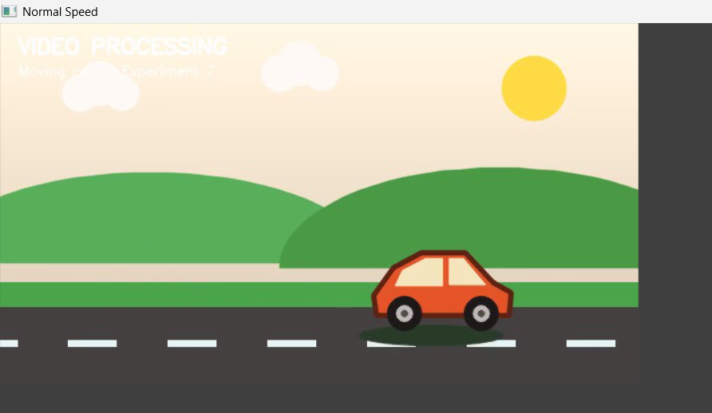
2. slow_motion.mp4 – Video played at half speed.
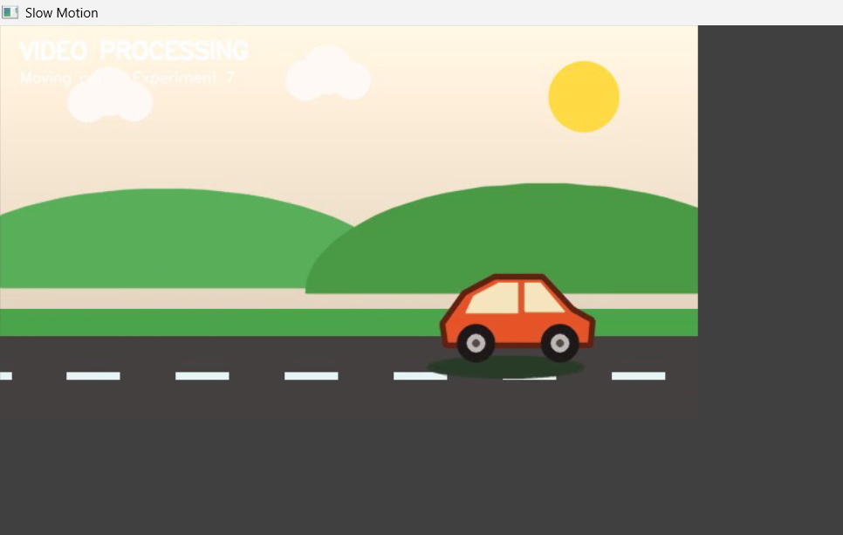

3.fast_motion.mp4 – Video played at approximately twice the speed.
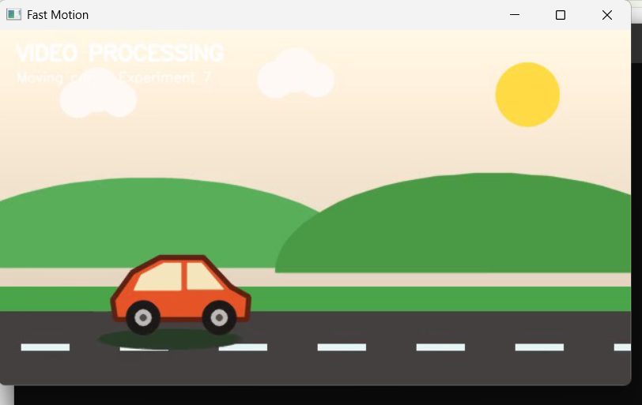

RESULT
Thus, the captured video was read and processed using Python and OpenCV. The video outputs for normal motion, slow motion, and fast motion were generated and saved successfully.

